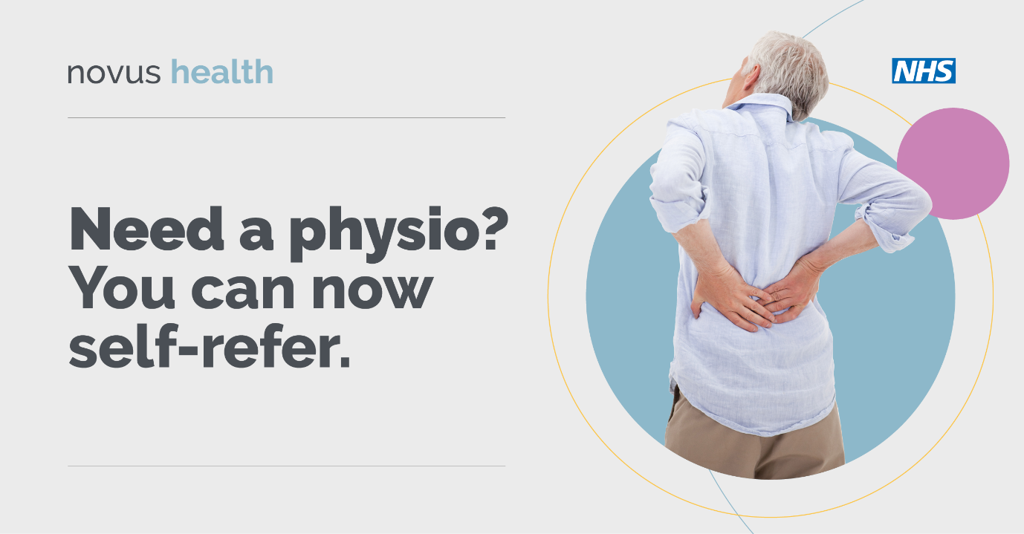

Patients aged 16 or over can now refer themselves directly for MSK physiotherapy without needing an appointment at your GP practice

Patients who wish to start the self-referral process can complete an online form at novushealth.co.uk or
call 01924 224497

